## Chapter 1. I2S

### 1.1 Overview

The DW_apb_i2s is a configurable, synthesizable, and programmable component designed to be used in

systems that process digital audio signals, such as:

■ A/D and D/A converters

■ digital signal processors

■ error correction for compact disc and digital recording

■ digital filters

■ digital input/output interfaces

The Inter-IC Sound (I2S) Bus is a simple three-wire serial bus protocol developed by Philips to transfer

stereo audio data. The bus only handles the transfer of audio data; hence control and subcoding signals need to be transferred separately using a different bus protocol (such as I2C).

### 1.2 Block Diagram

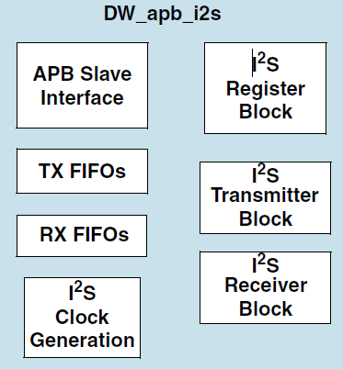

Fig. 1.1 I2S module block diagram

### 1.3 Features

DW_apb_i2s has the following features:

■ APB data bus widths of 8, 16, and 32 bits  
■ I2S transmitter and/or receiver based on the Philips I2S serial protocol

■ Configurable number of stereo channels (up to 4) for both transmitter and receiver   
■ Full duplex communication due to the independence of transmitter and receiver   
■ Asynchronous clocking of APB bus and I2S sclk

■ Master or slave mode of operation

■ Audio data resolutions of 12, 16, 20, 24, and 32 bits   
■ External sclk gating and enable signals

■ Configurable FIFO depth of 2, 4, 8, and 16 words, where the wordsize is determined by

*I2S_RX_WORDSIZE_x* or *I2S_TX_WORDSIZE_*r

■ Configurable support for programmable DMA registers   
■ Programmable FIFO thresholds

■ Component parameters for configurable software driver support